**VISVESVARAYA TECHNOLOGICAL UNIVERSITY**

**“JNANA SANGAMA”, BELAGAVI – 590 018**

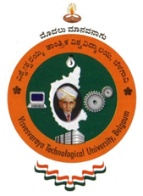

PROJECT REPORT ON

“AIRTOUCH: GESTURE AND VOICE COMMAND INTERFACE FOR PCS”

Submitted in partial fulfilment of the requirement

for the award of the degree of

**Bachelor of Engineering**

**In**

**Computer Science and Engineering**

**Submitted By**

|  |  |  |
| --- | --- | --- |
| RAKSHITH G M | : | 4GH21CS033 |
| POOJA P | : | 4GH21CS030 |
| RAVIKIRAN | : | 4GH21CS036 |
| LAKSHMI H R | : | 4GH21CS019 |

**Under the Guidance of**

Dr. Vani V G, BE, M. Tech, Ph.D.

Head of the Department

**DEPARTMENT OF COMPUTER SCIENCE & ENGINEERING**

**GOVERNMENT ENGINEERING COLLEGE, HASSAN - 573201**

**2024-25**

**GOVERNMENT ENGINEERING COLLEGE HASSAN – 573 201**

Affiliated to VTU, Belagavi & Approved by AICTE, New Delhi

**Department of Computer Science & Engineering**

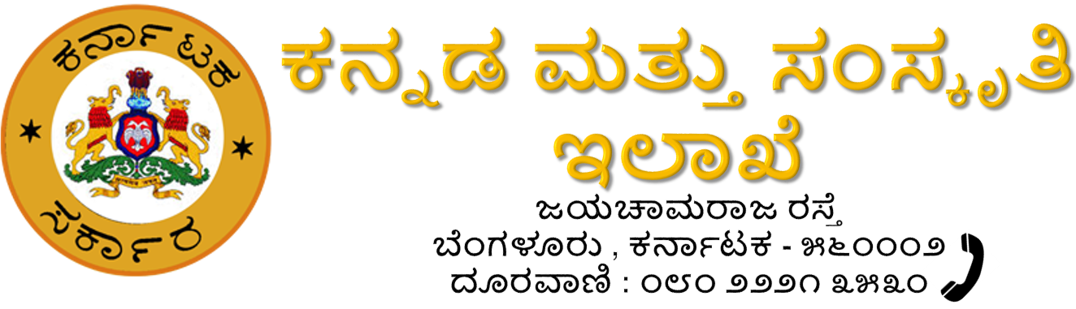

**CERTIFICATE**

Certified that the Project work entitled “AIRTOUCH: GESTURE AND VOICE COMMAND INTERFACE FOR PCS” carried out by **Mr. Rakshith G M (4GH21CS033), Ms. Pooja P (4GH21CS030), Mr. Ravikiran (4GH21CS036) and Ms. Lakshmi H R (4GH21CS019)**  a bonafide students of **Government Engineering College Hassan** in partial fulfillment for the award of **Bachelor of Engineering** in **Computer Science and Engineering** of the **Visvesvaraya Technological University**, **Belagavi** during the year 2024-2025. It is certified that all correction / suggestions indicated during internal evaluation has been incorporated in the report. The Project report has been approved as it satisfies the academic requirements in respect of Project work prescribed for the said Degree.



Prof. Kiran M P

Project Co-Ordinator

Dr. Girish D P

Principal

Dr. Vani V G

Guide and HoD

Dept of CSE

Name of the examiners Signature with date  
1. …………………….  
2. …………………….